**EXP 8)** Create a simple cloud web application for student counselling system using any Cloud Service Provider to demonstrate SaaS with the fields of student name, age, address, phone, subjects studied, Year of passing, percentage of marks, domain interest, etc

**PROCEDURE:**

**STEP 1:** GOTO ZOHO.COM

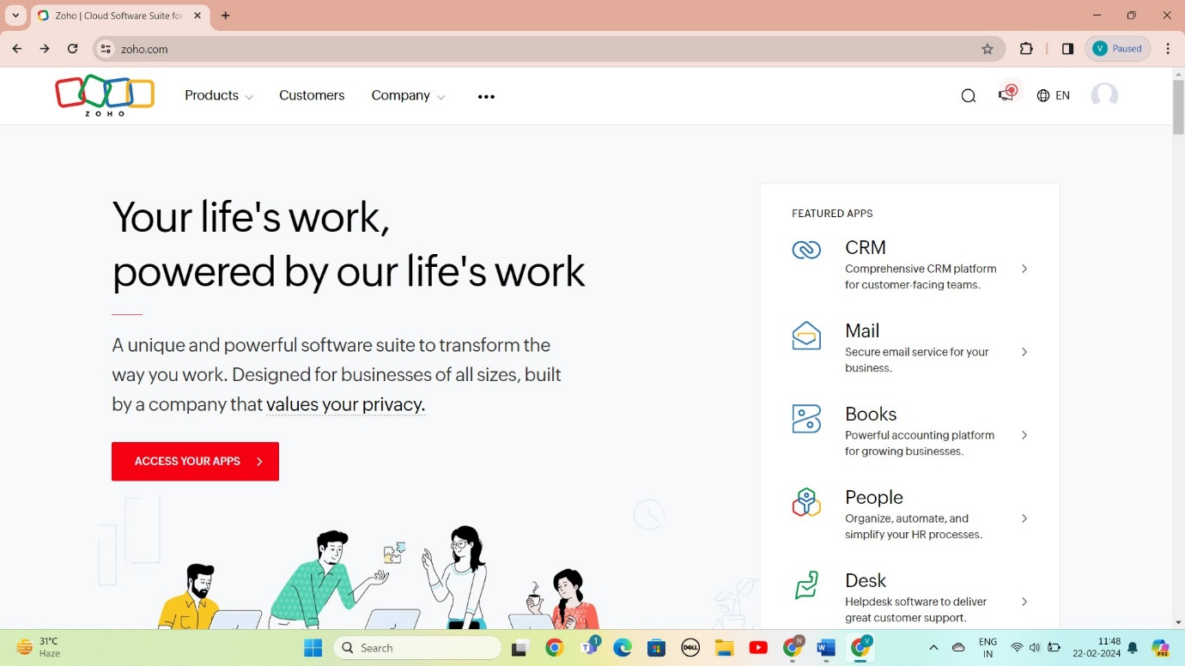

STEP 2: LOGIN TO THE ZOHO.COM

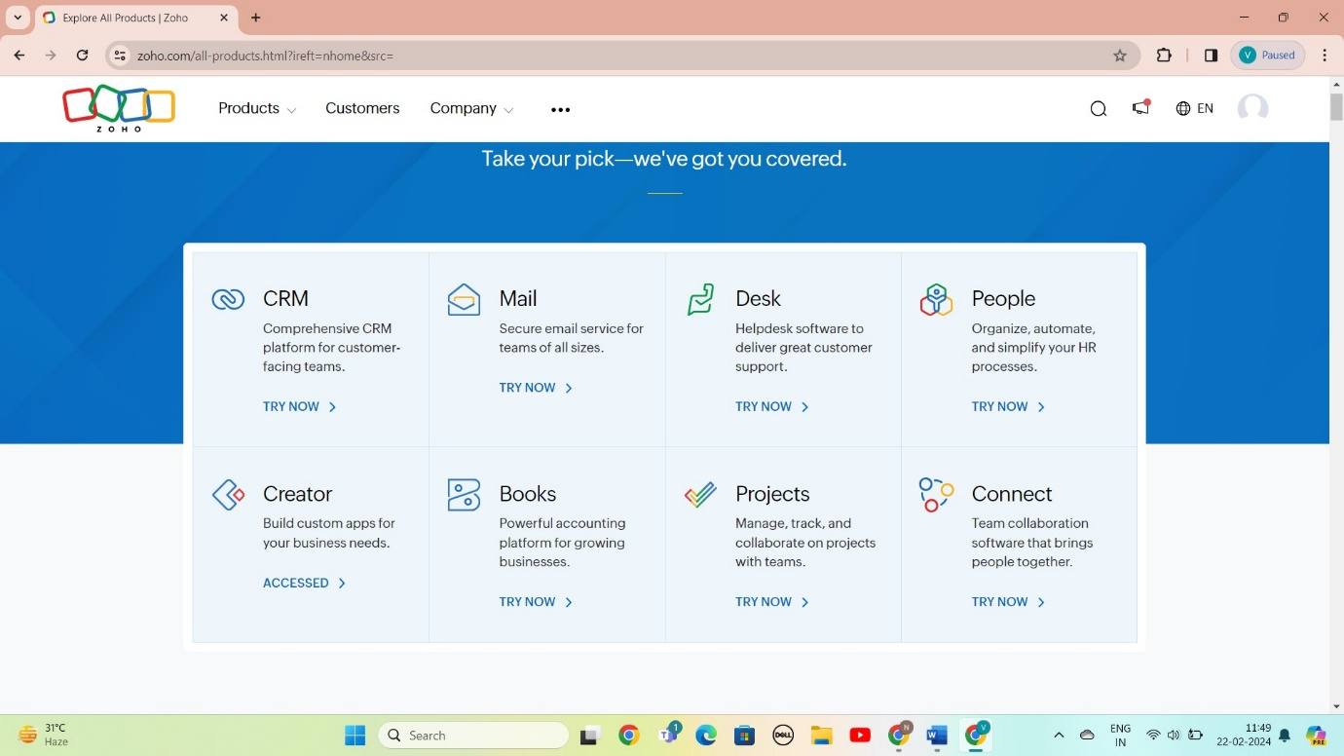

STEP 3: SELECT A CREATE FROM SCRATCH

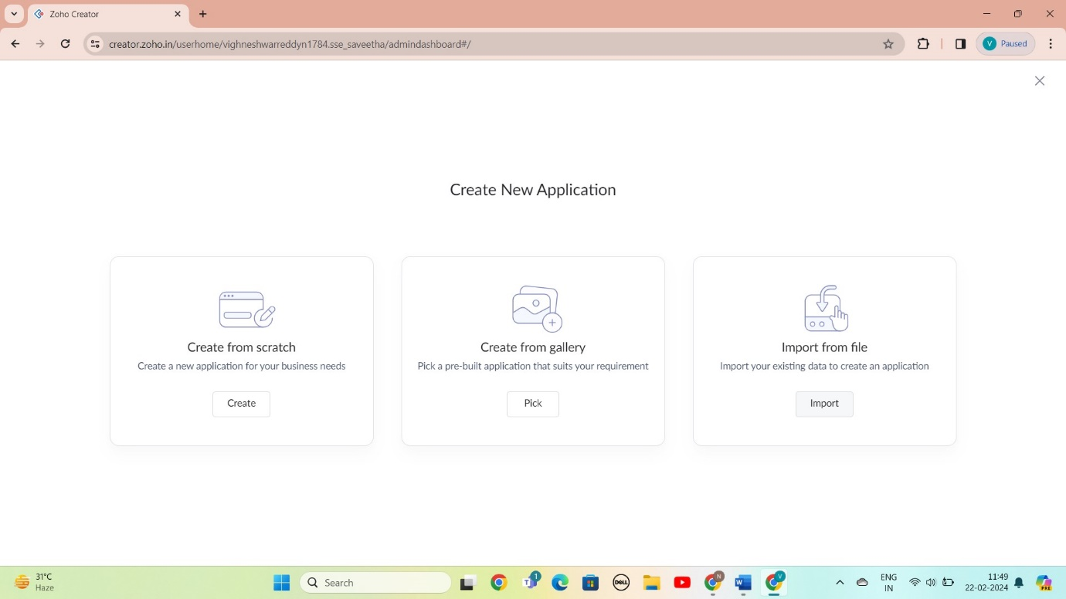

STEP 4: SELECT APPLICATION NAME AS student counselling system

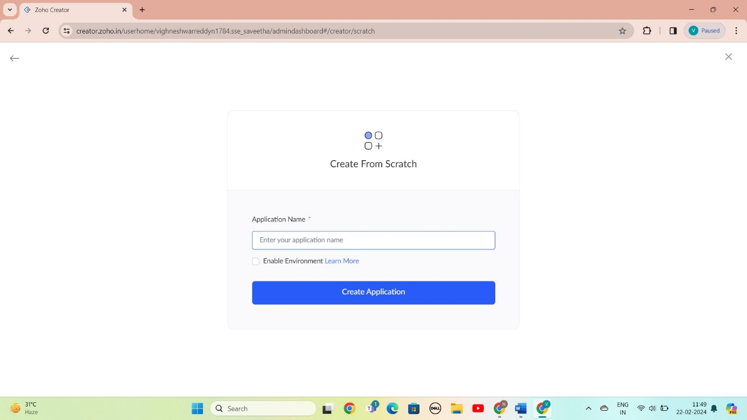

STEP 5: CREATED NEW FORM

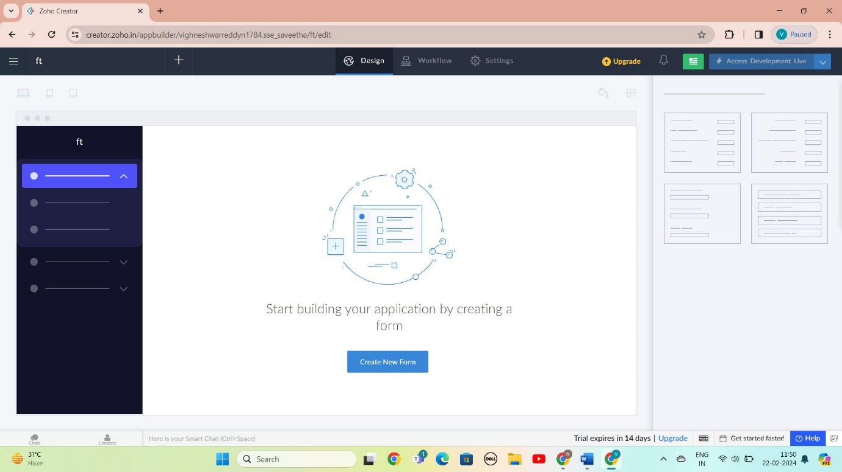

STEP 6: SELECT BASIC FILED FROM GIVEN BELOW AND DEVELOP APPLICATION

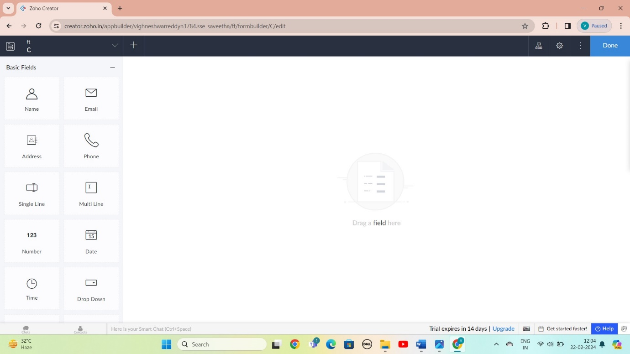

STEP 7: THE SOFTWARE AS BEEN CREATE STUDENT

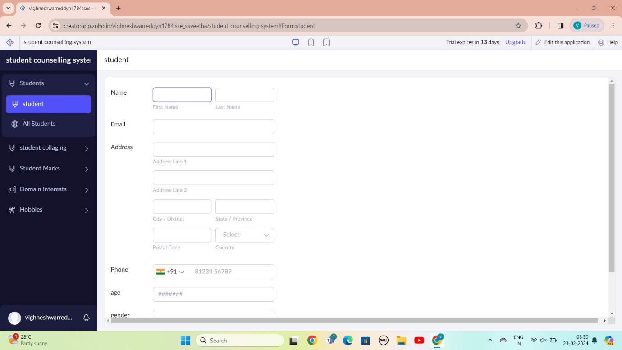

STEP 8: THE SOFTWARE AS BEEN CREATE STUDENT WHERE HE STUDIED

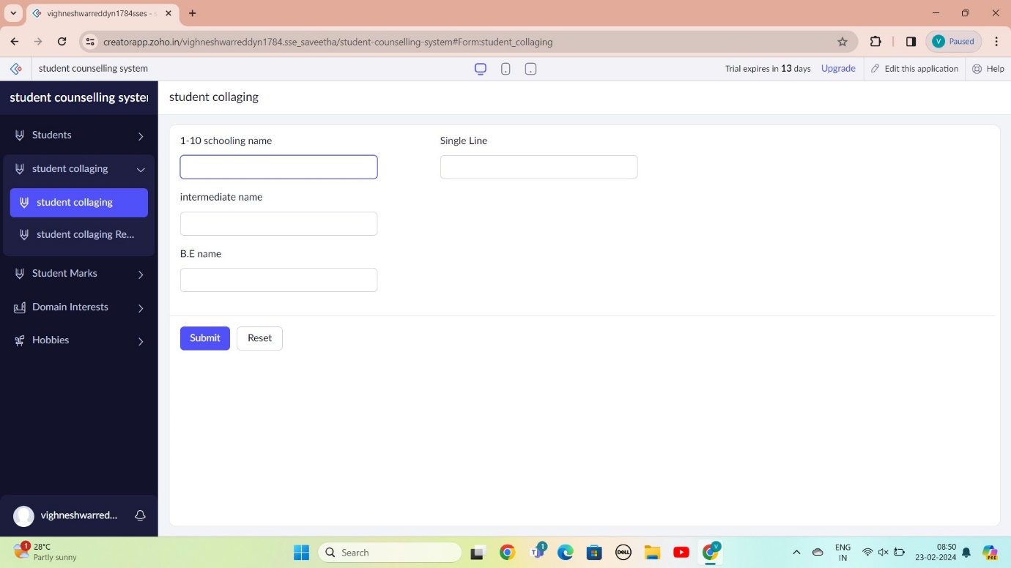

STEP 9: THE SOFTWARE AS BEEN CREATE MARKS

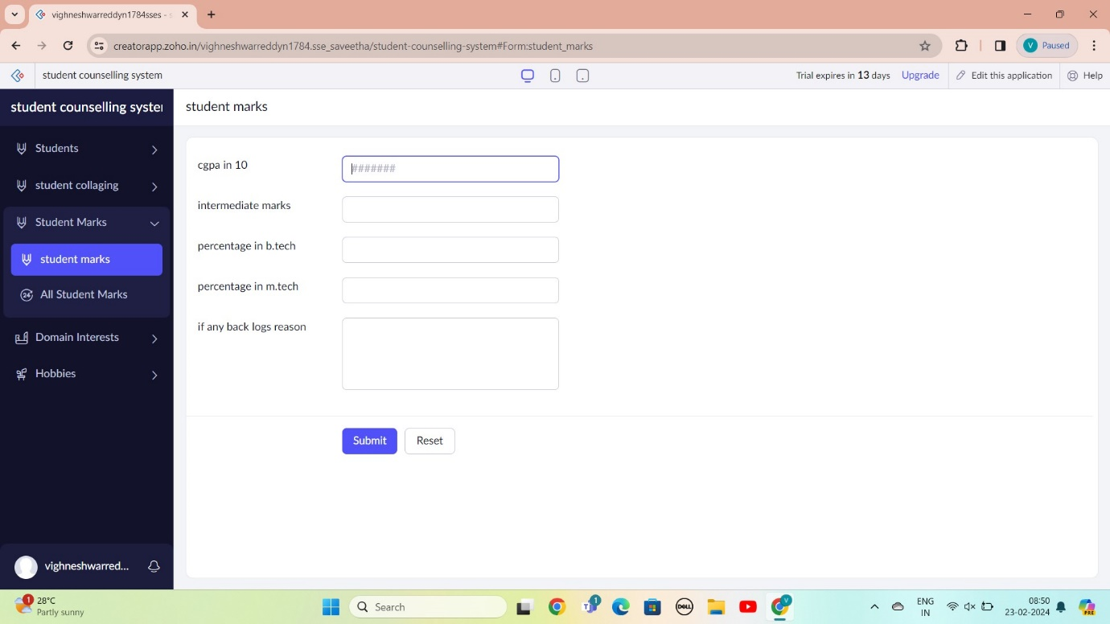

STEP 10: THE SOFTWARE AS BEEN CREATE DOMINE INTEREST

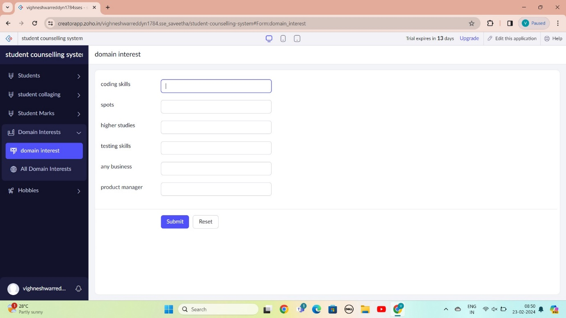

STEP 11: THE SOFTWARE AS BEEN CREATE HOBBIES

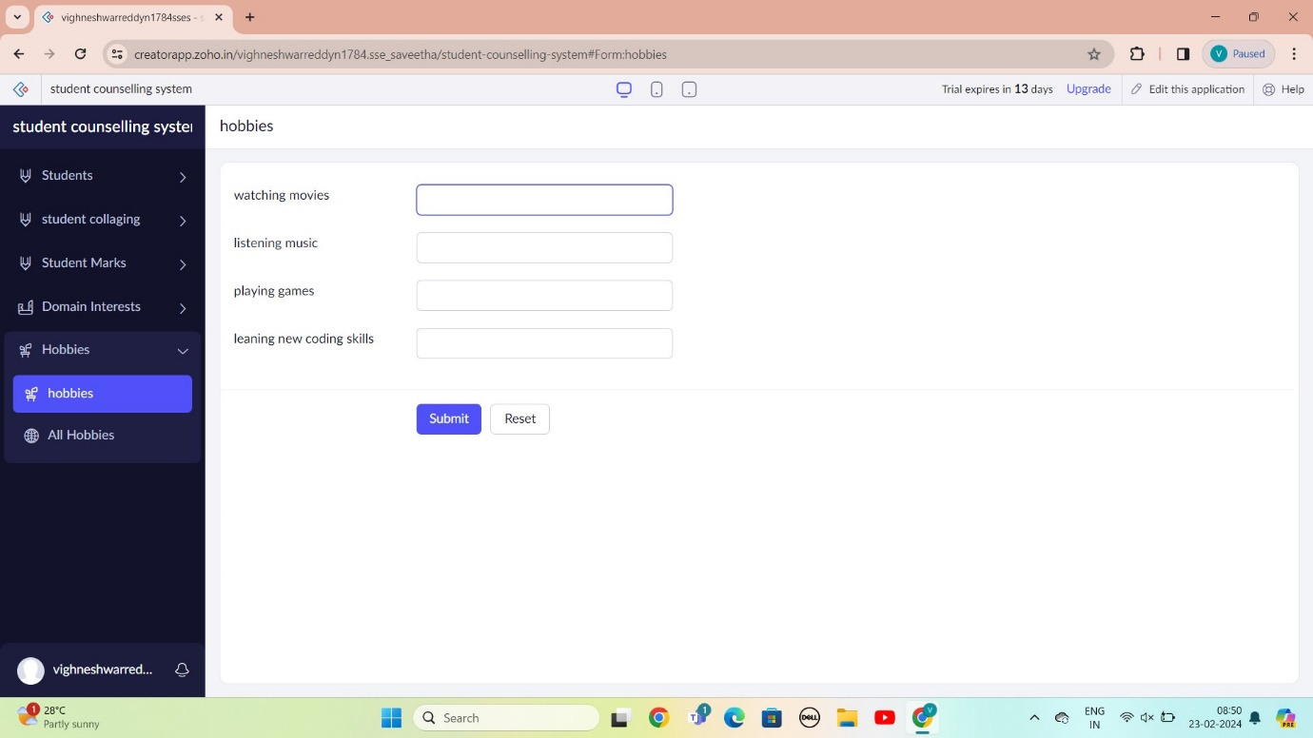

STEP 12: THE SOFTWARE AS BEEN CREATE

